1. Create a new instance on Amazon EC2 by Launching instance

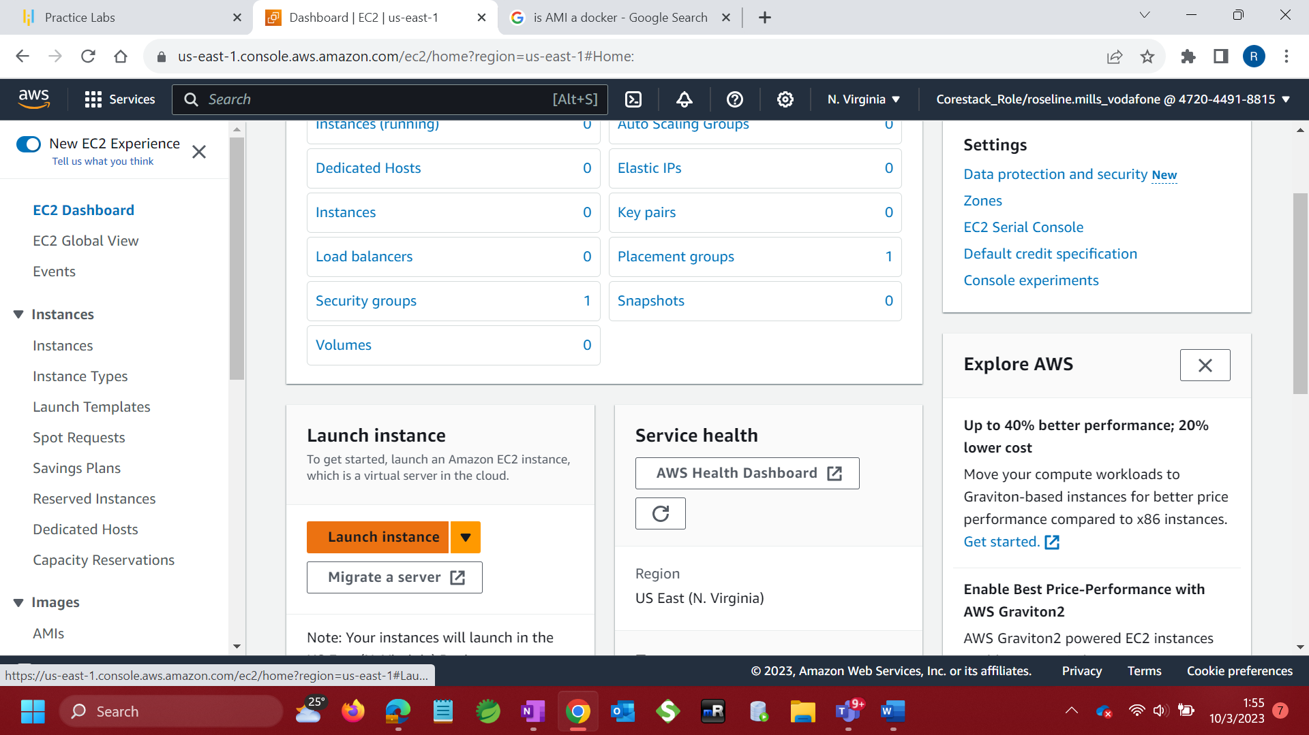

1. Add name

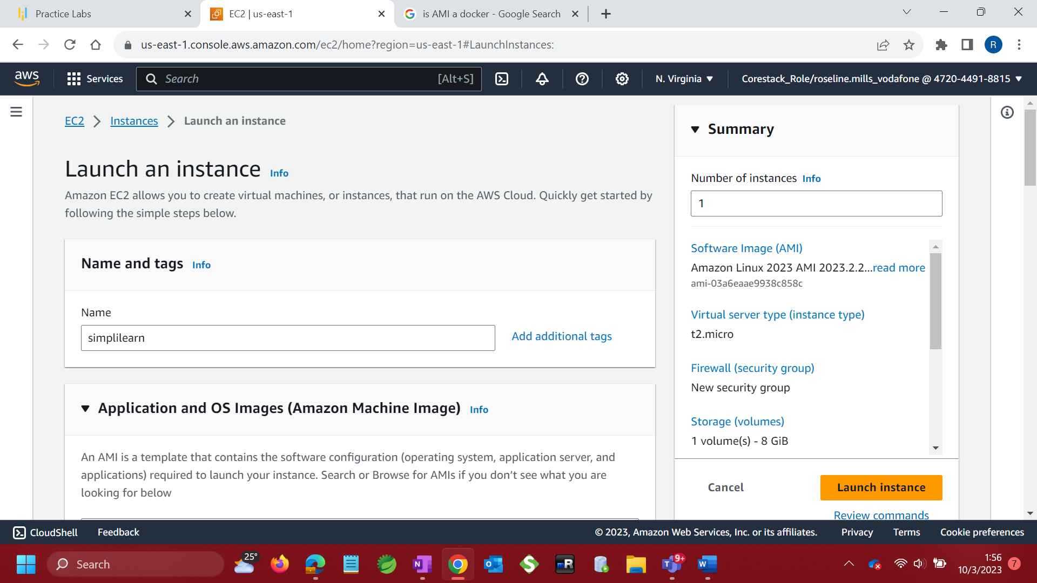

1. Select Application and OS image

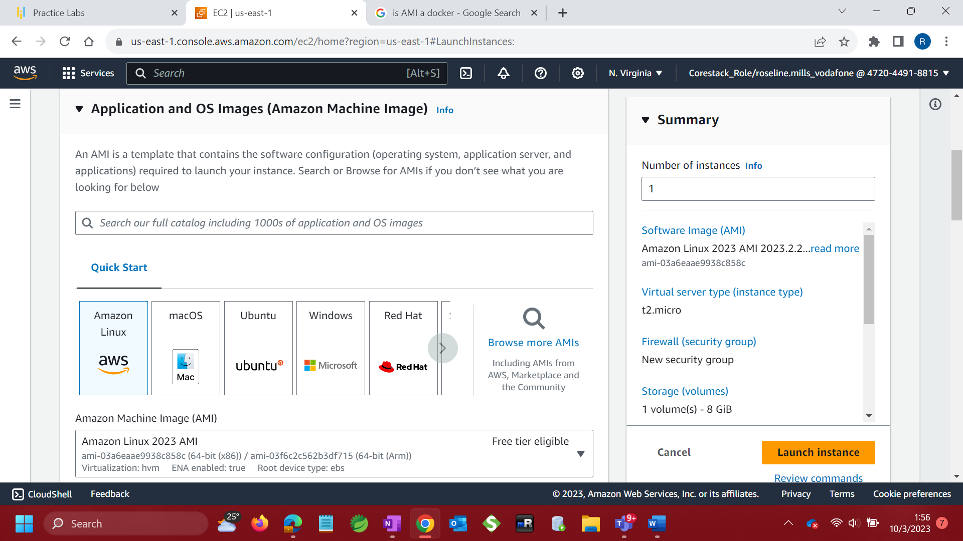

1. Select instance type

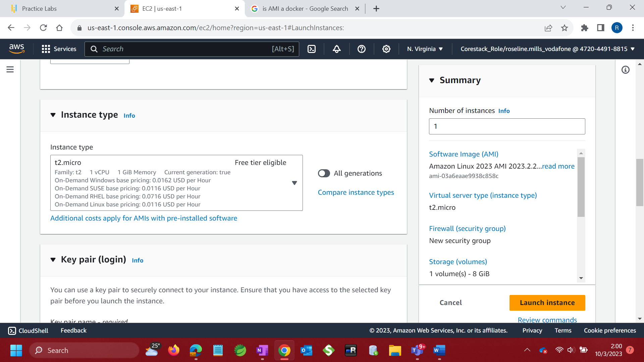

1. Create a new key pair (login)

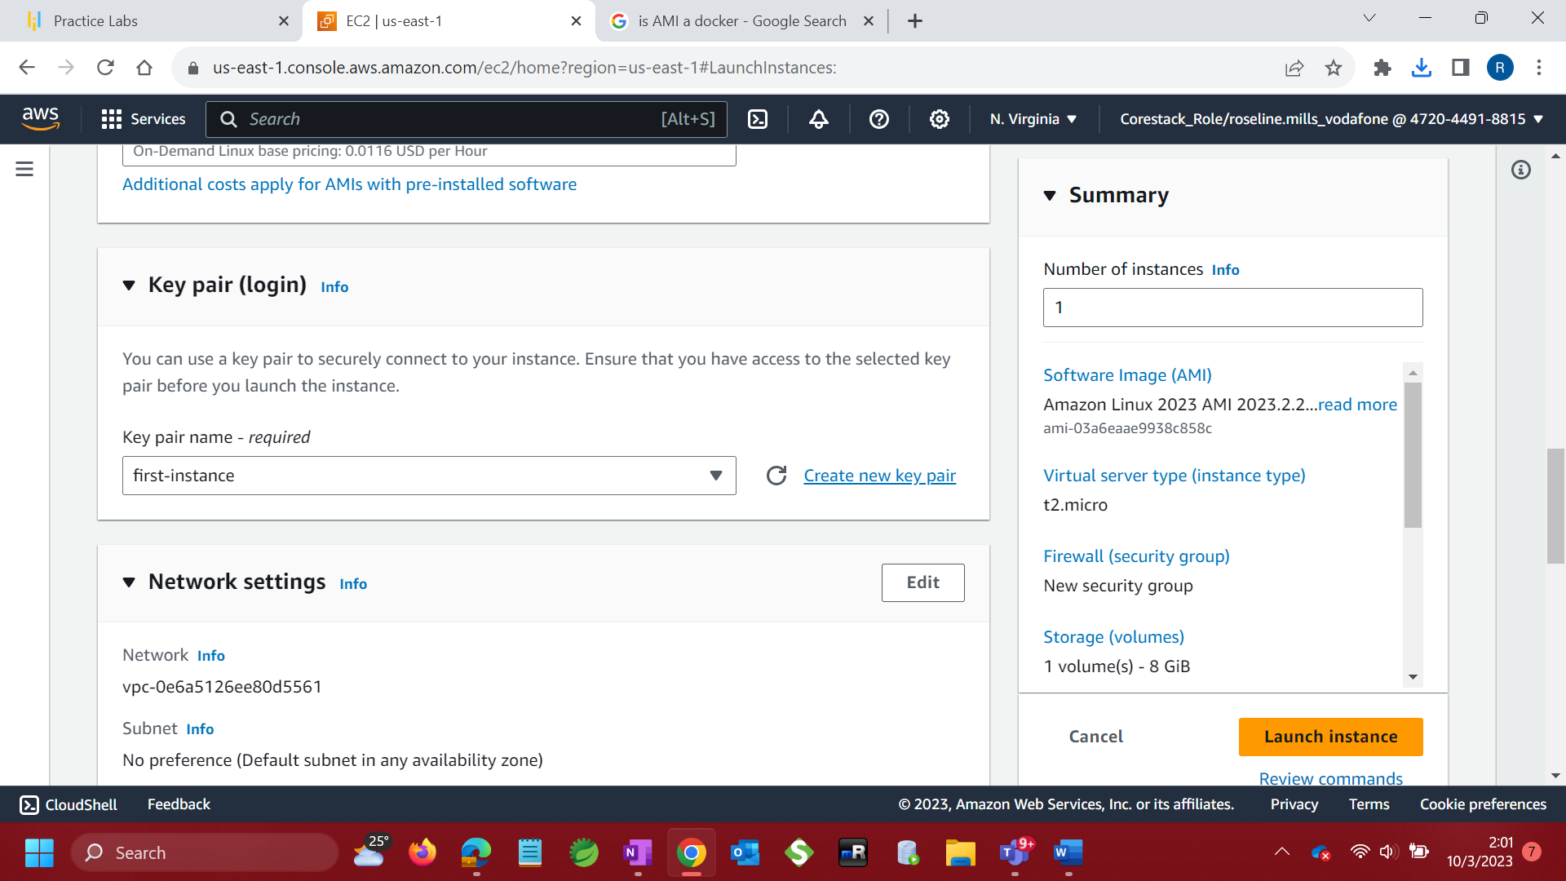

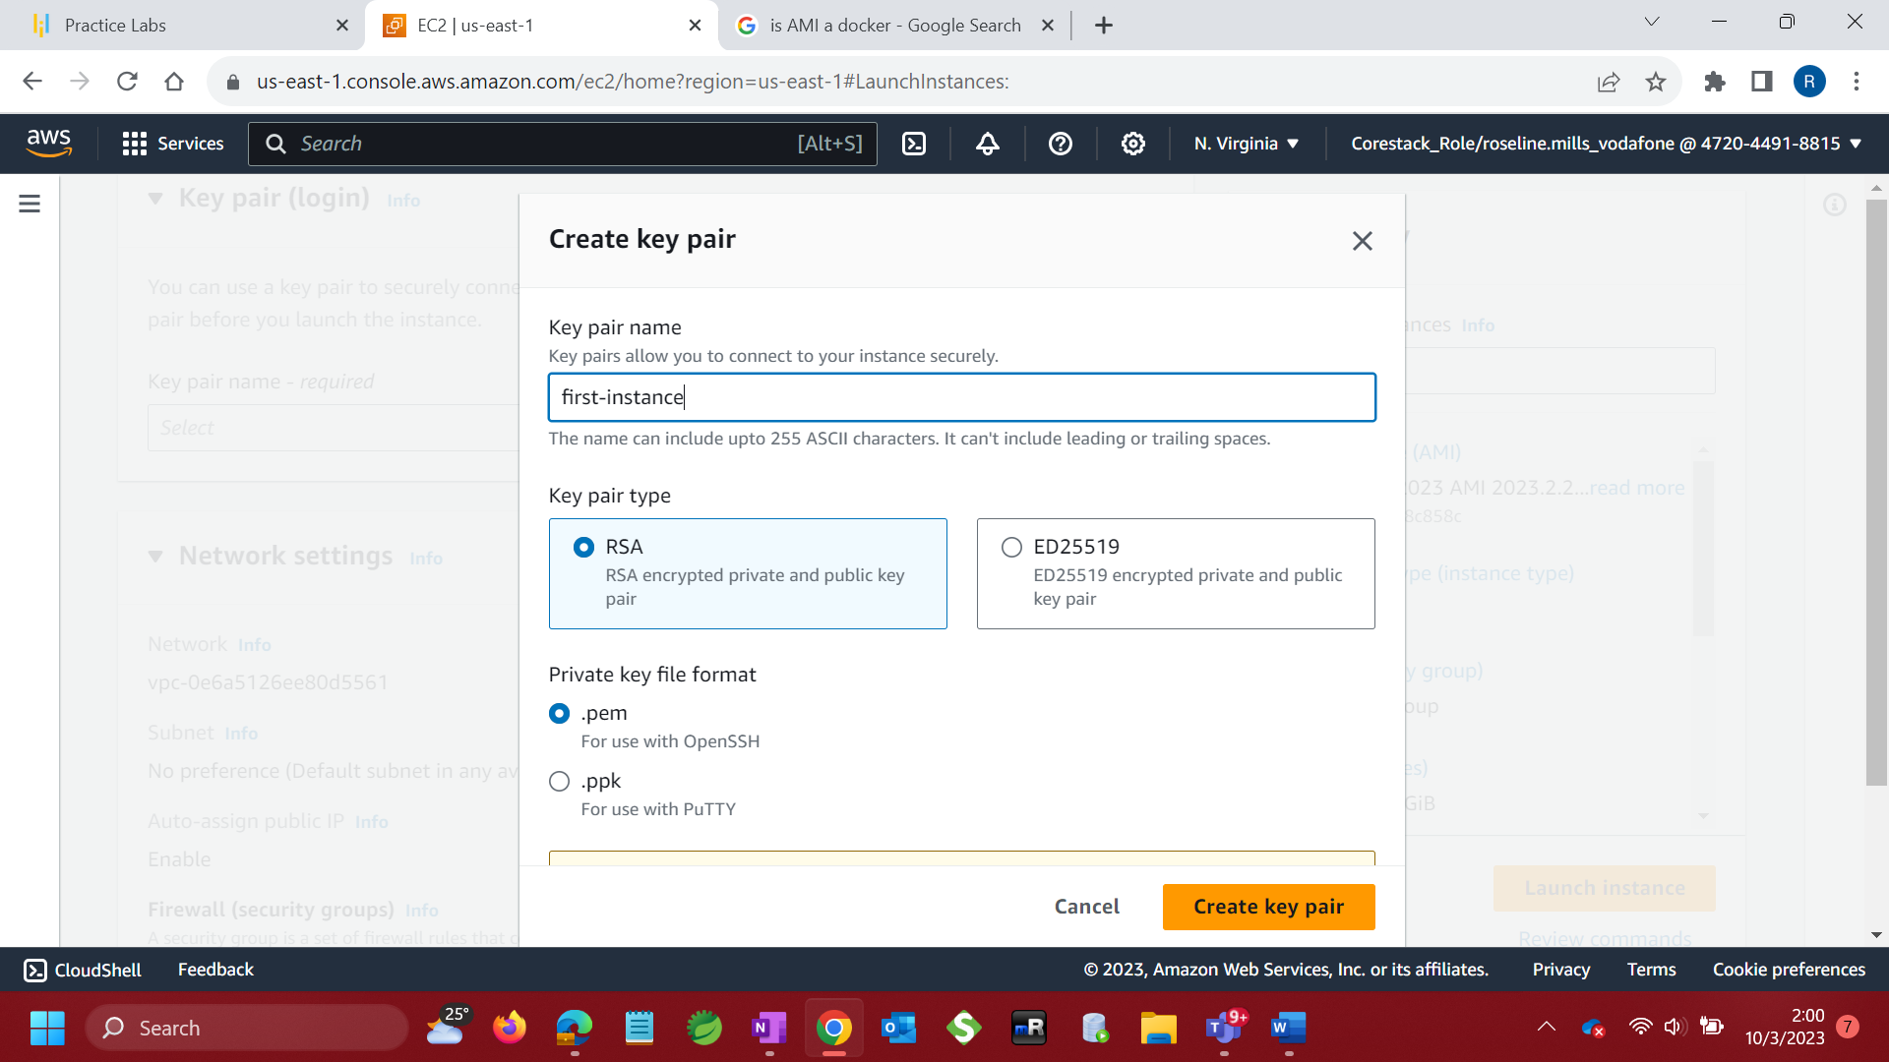

1. Network settings – Allow SSH

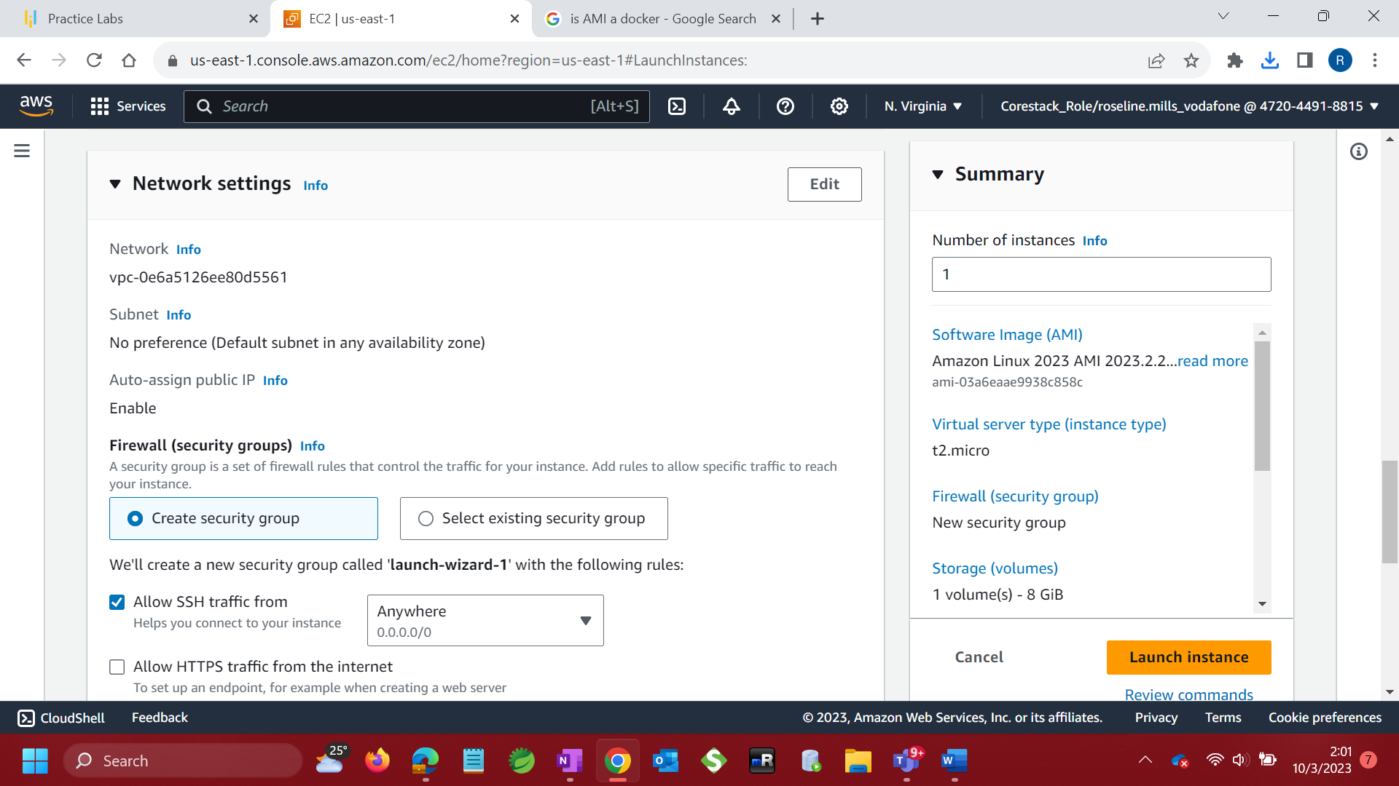

1. Configure Storage

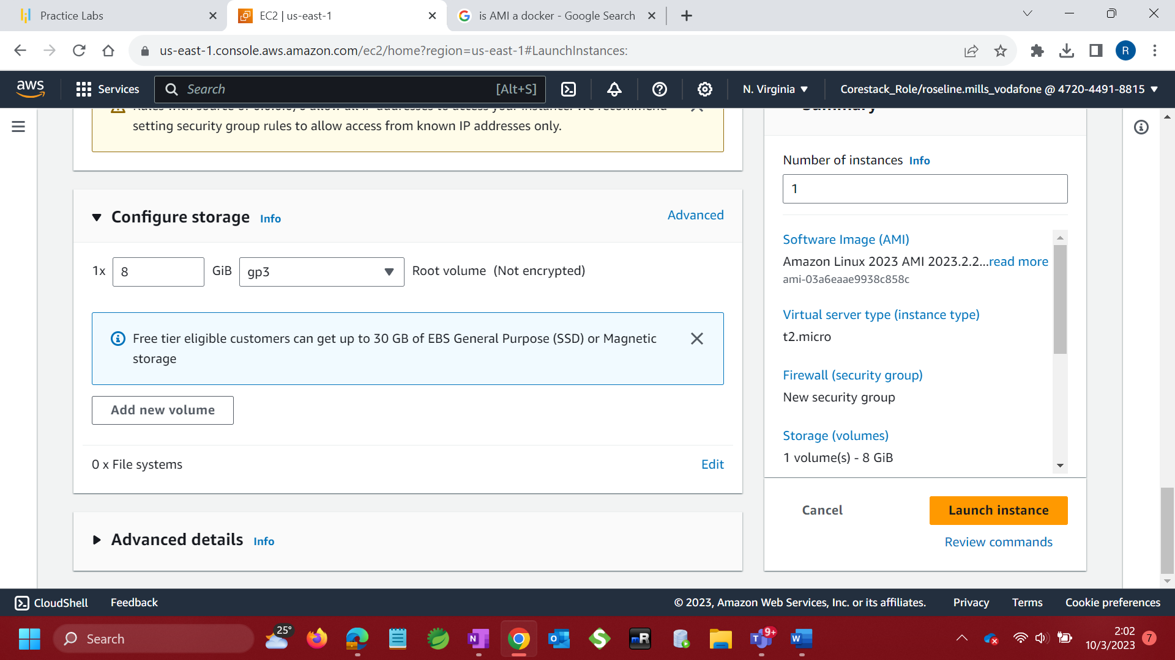

1. Launch instance

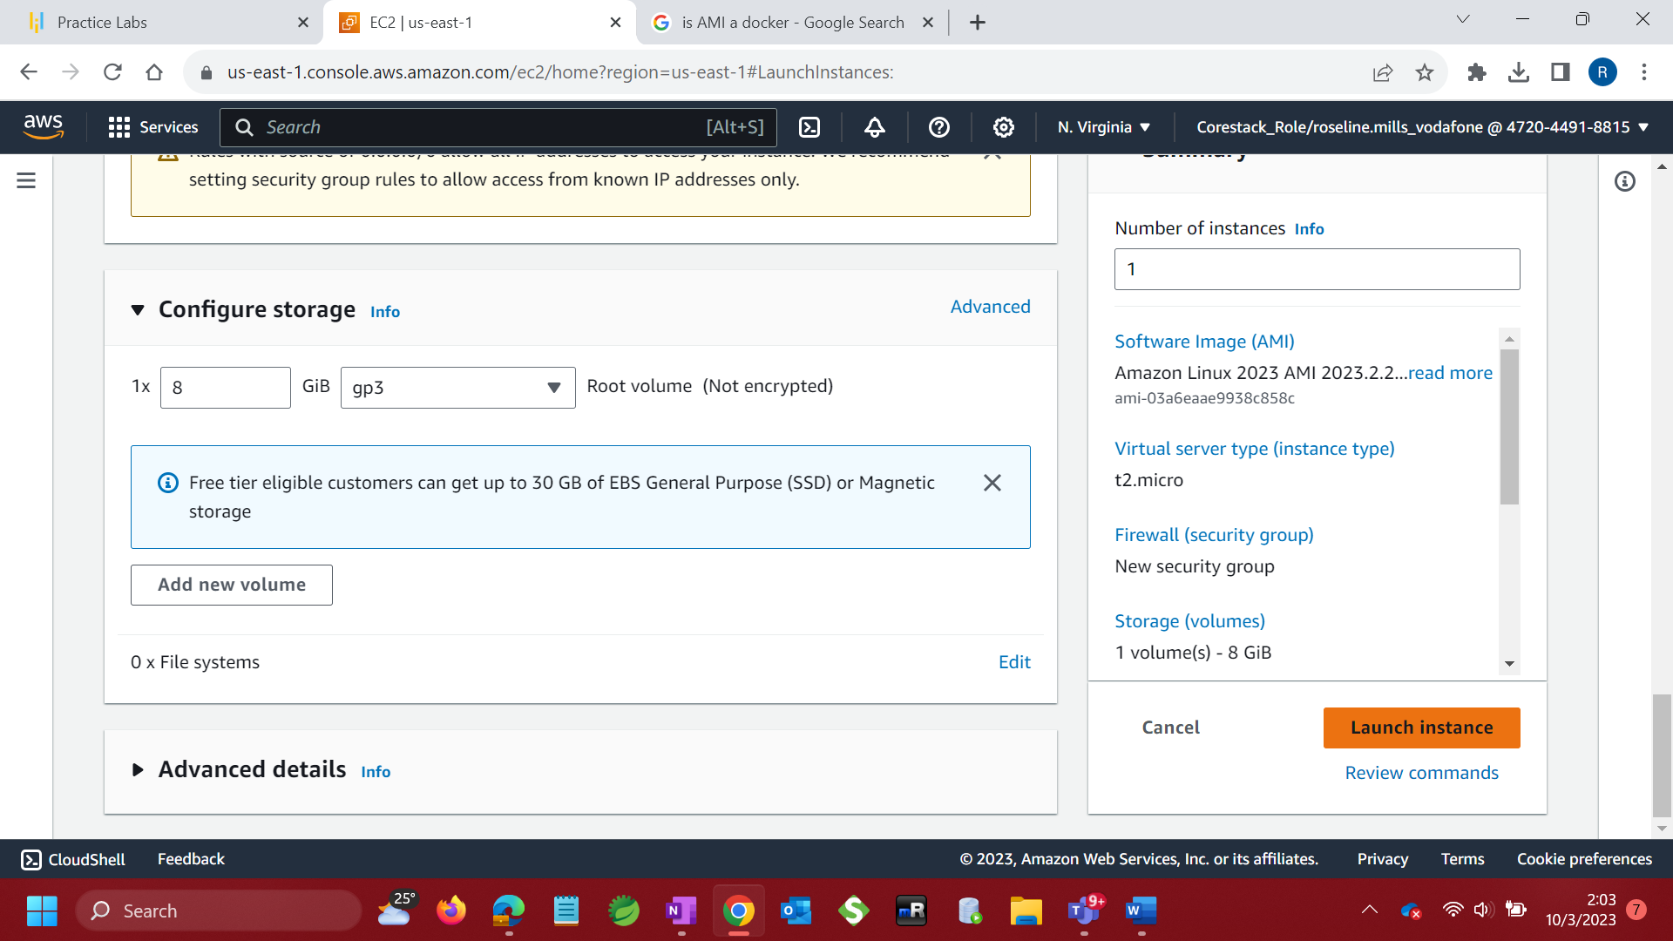

1. Successfully initiated instance

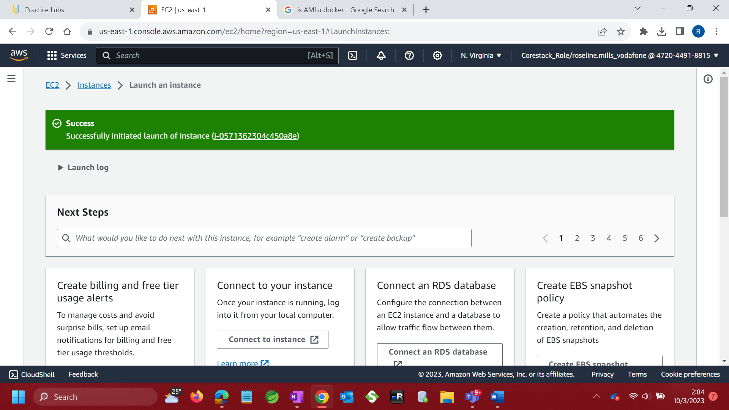

1. View Running instance

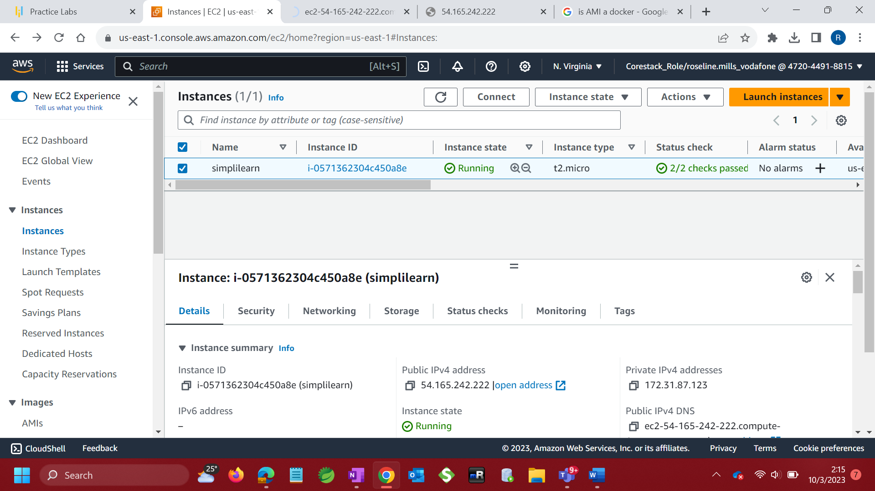

1. Connect to instance



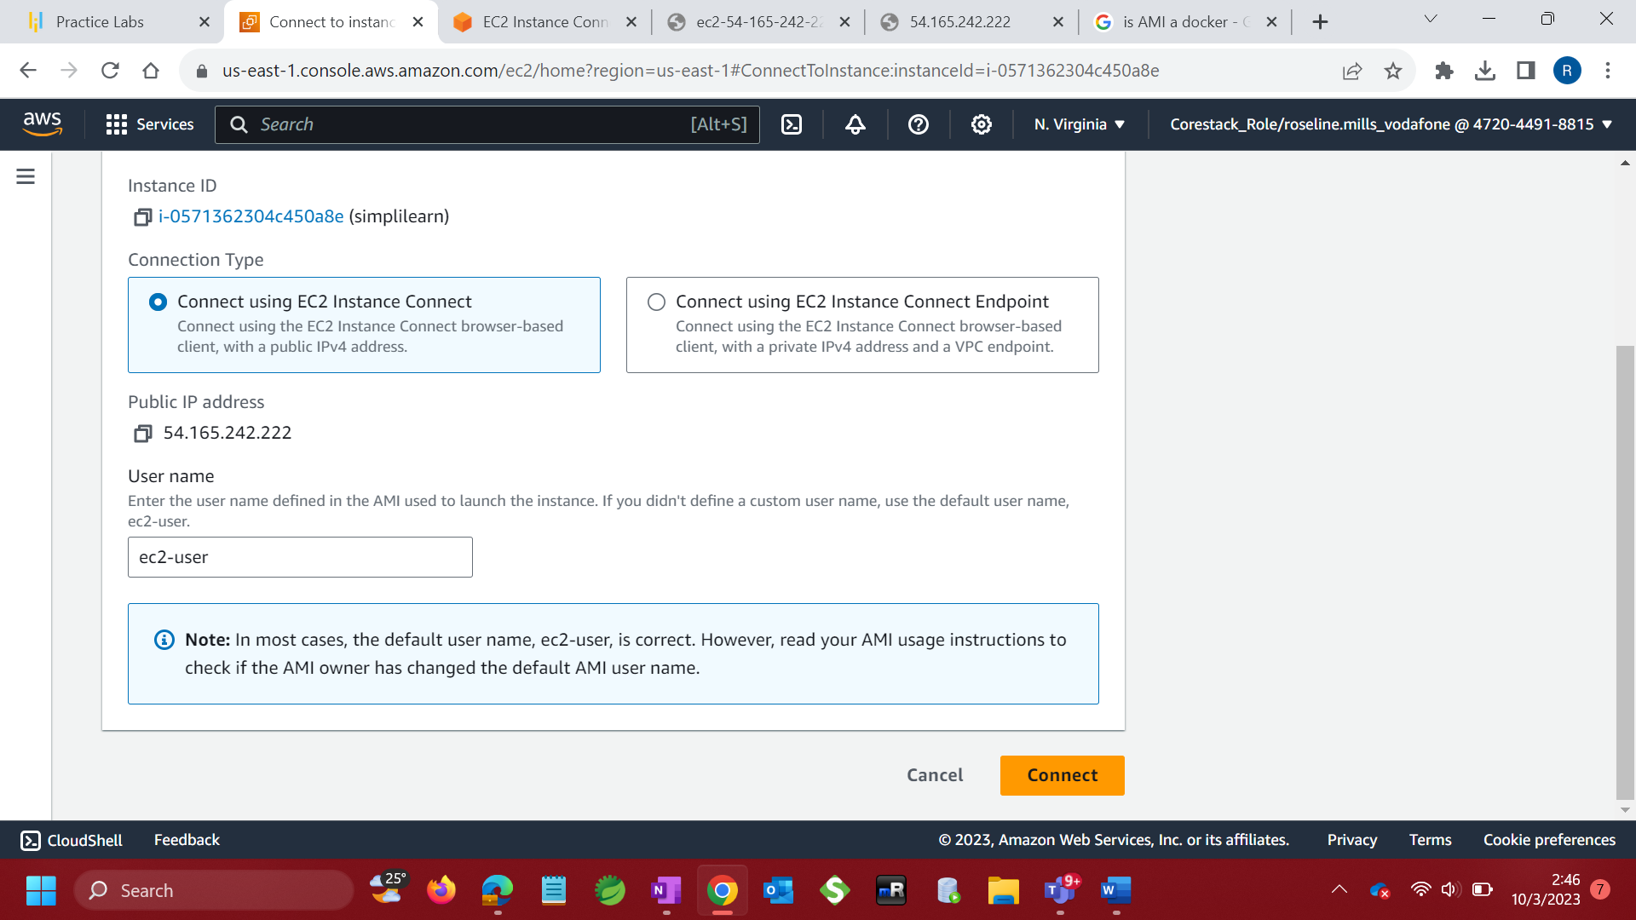

1. **sudo su**
2. **yum update -y** to update OS if necessary
3. Spawn http server with command **yum install -y httpd.x86_64**
4. systemctl start httpd.service
5. systemctl enable httpd.service

**Download and install Jenkins with the commands**

* sudo wget -O /etc/yum.repos.d/jenkins.repo \

<https://pkg.jenkins.io/redhat-stable/jenkins.repo>

* sudo rpm --import <https://pkg.jenkins.io/redhat-stable/jenkins.io-2023.key>
* sudo yum upgrade

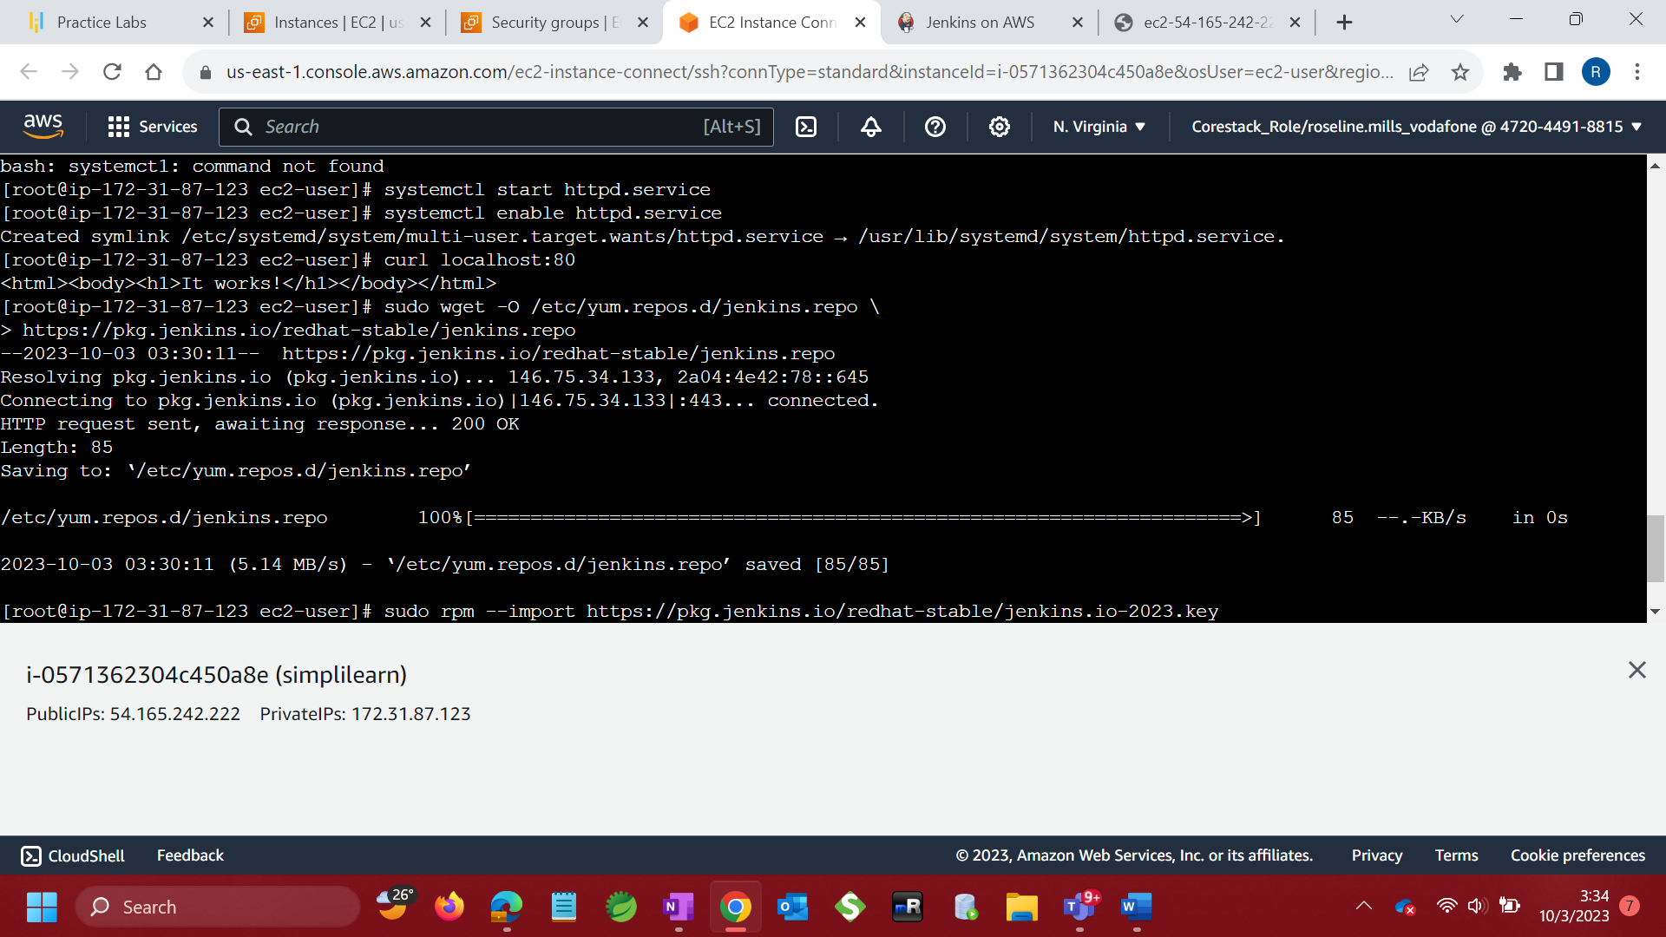

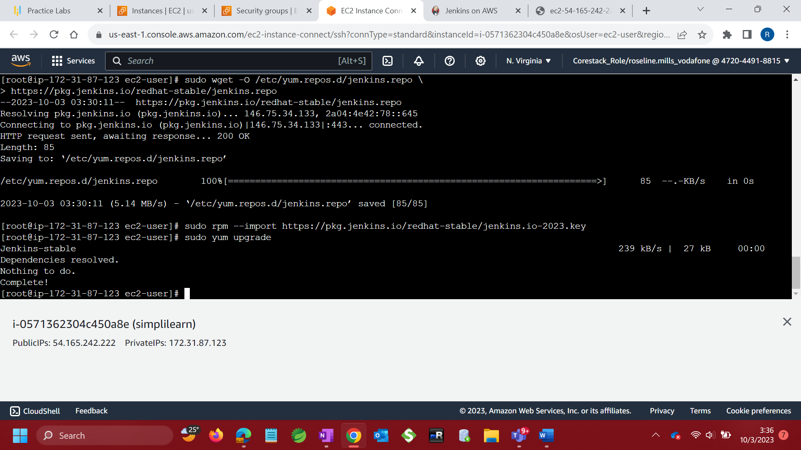

Install Java (Amazon Linux 2023):

With command - sudo dnf install java-17-amazon-corretto -y

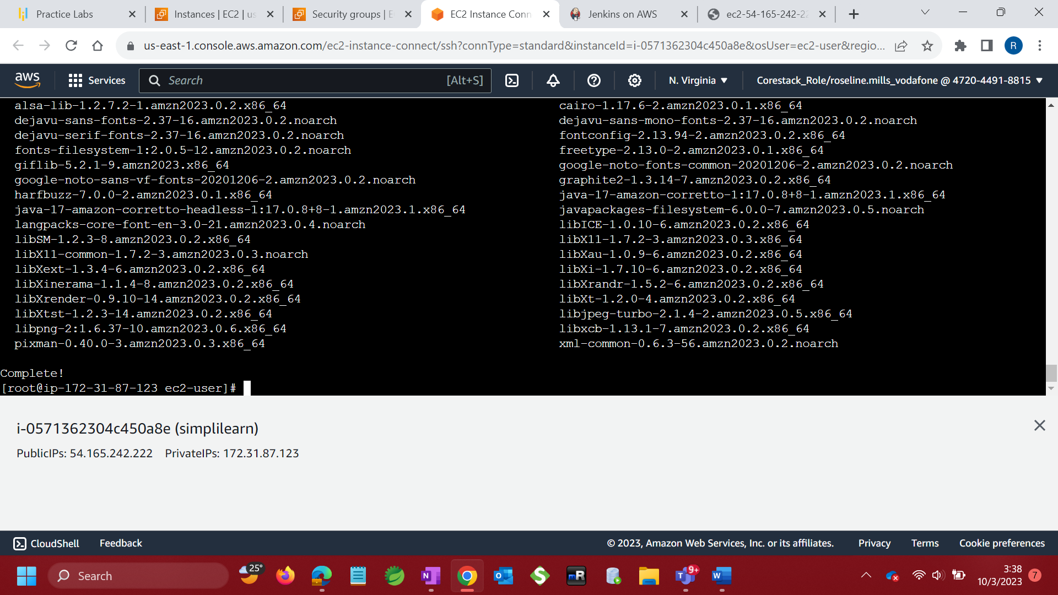

Install Jenkins

sudo yum install jenkins -y

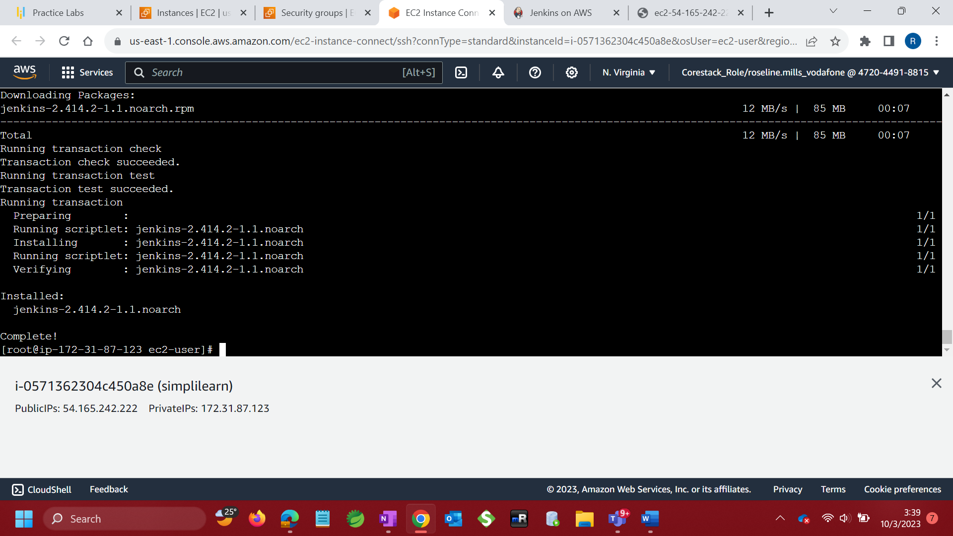

Edit inbound Rules – Add new rule to allow port 8080

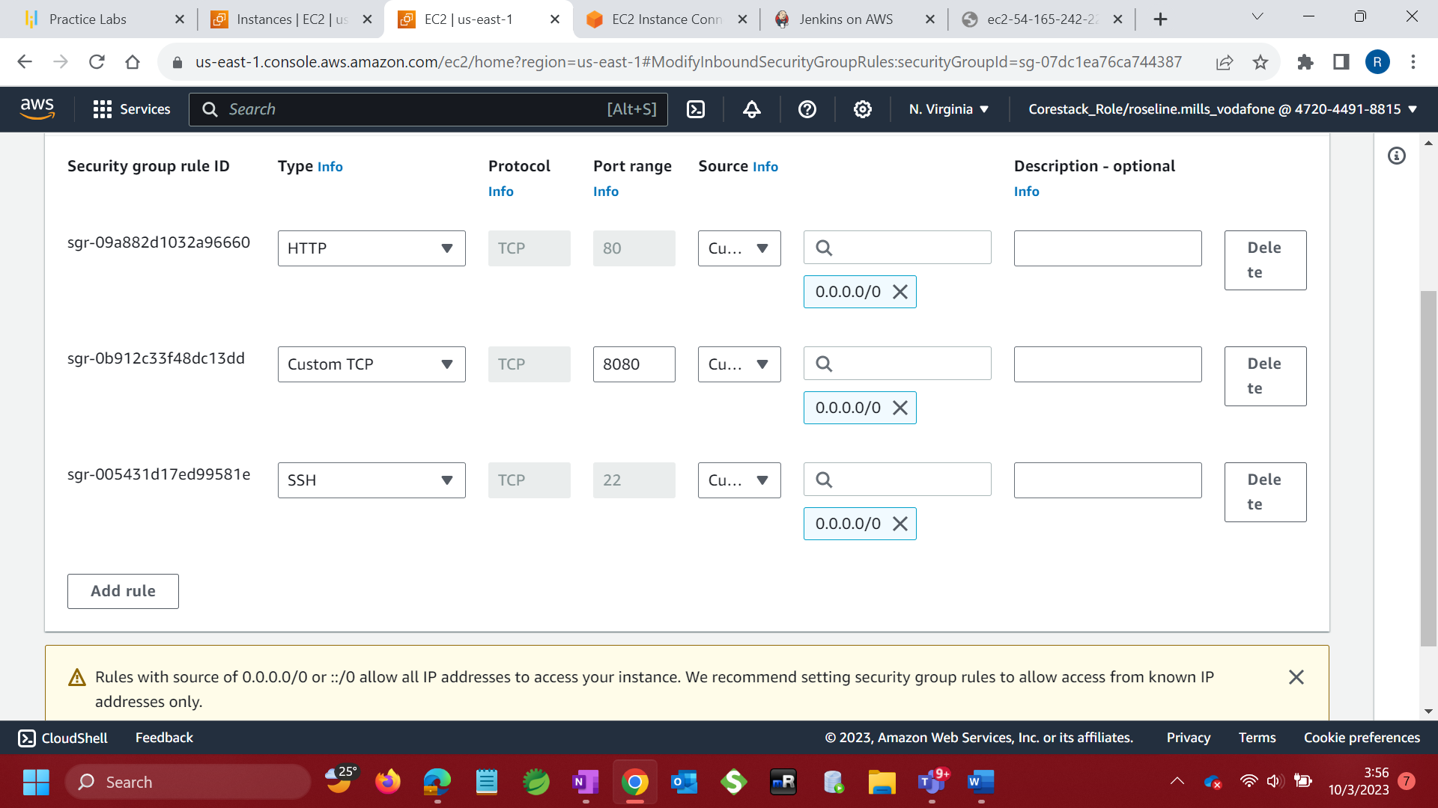

Access Jenkins on public IP over port 8080

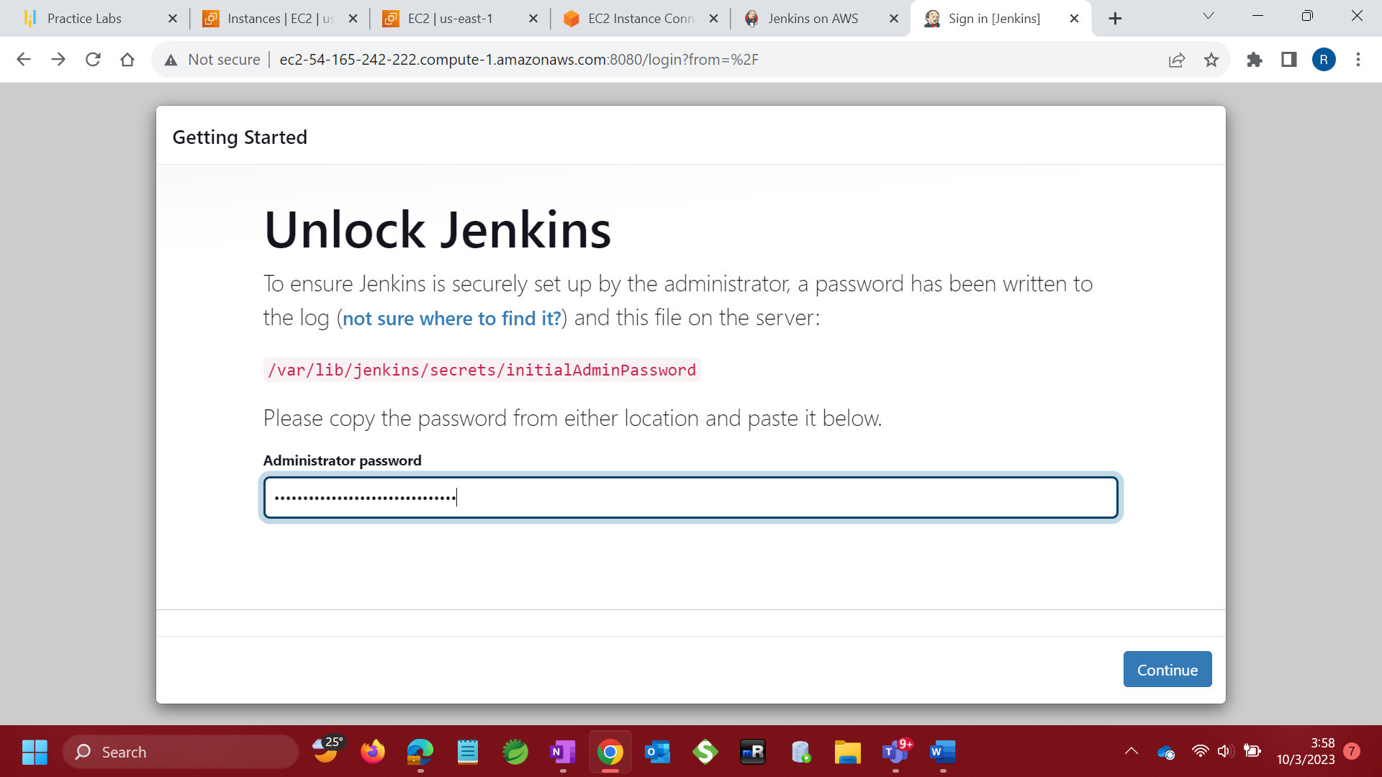

Install suggested plugins

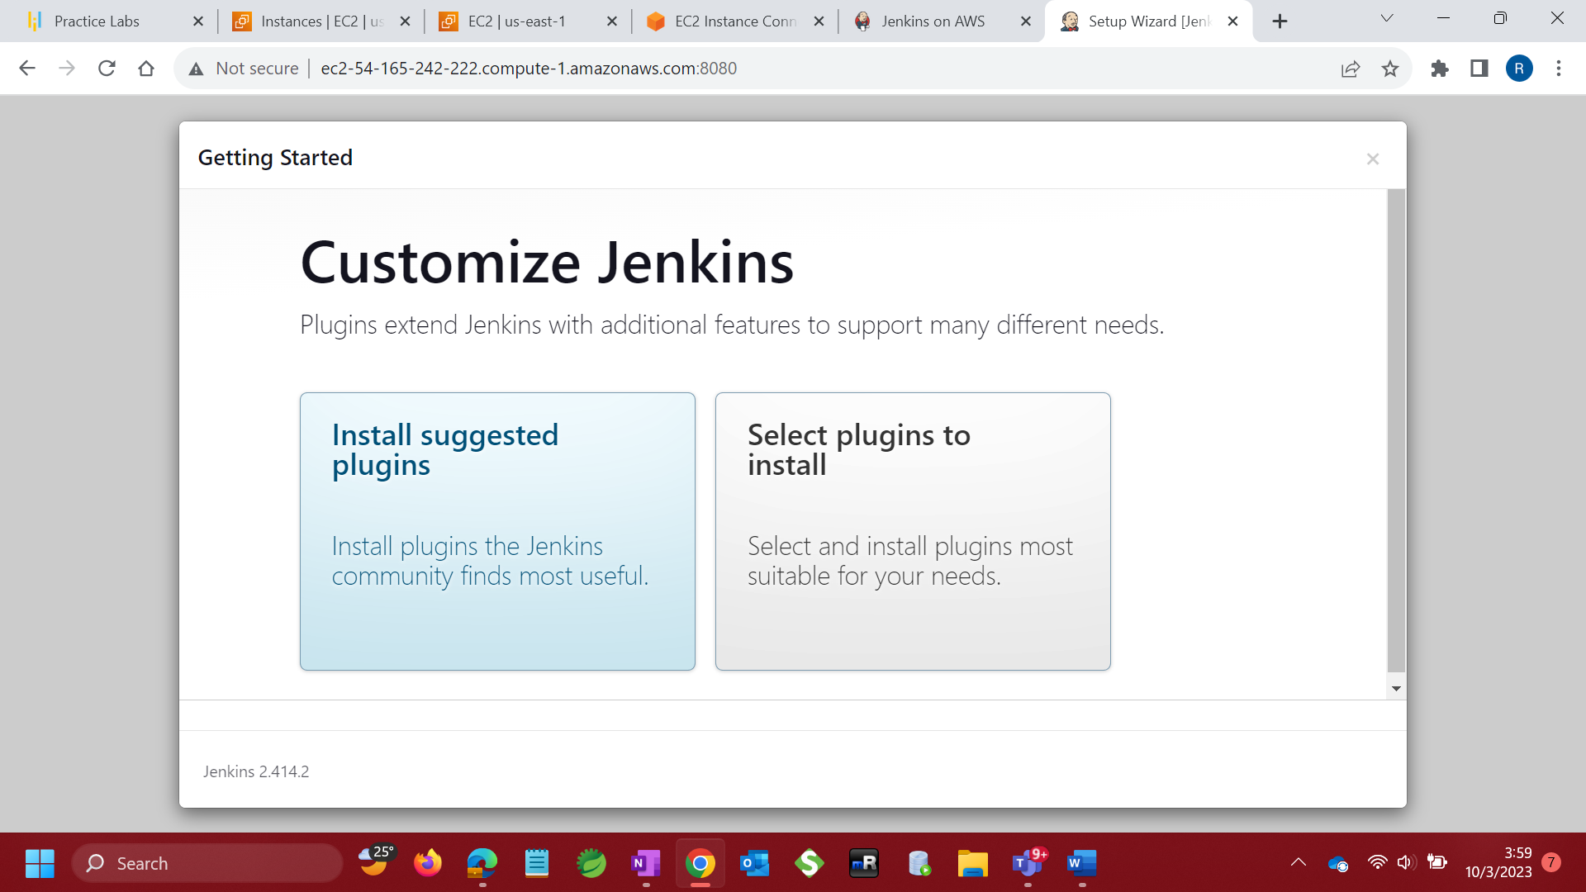

Install maven on EC2 instance

sudo yum install maven

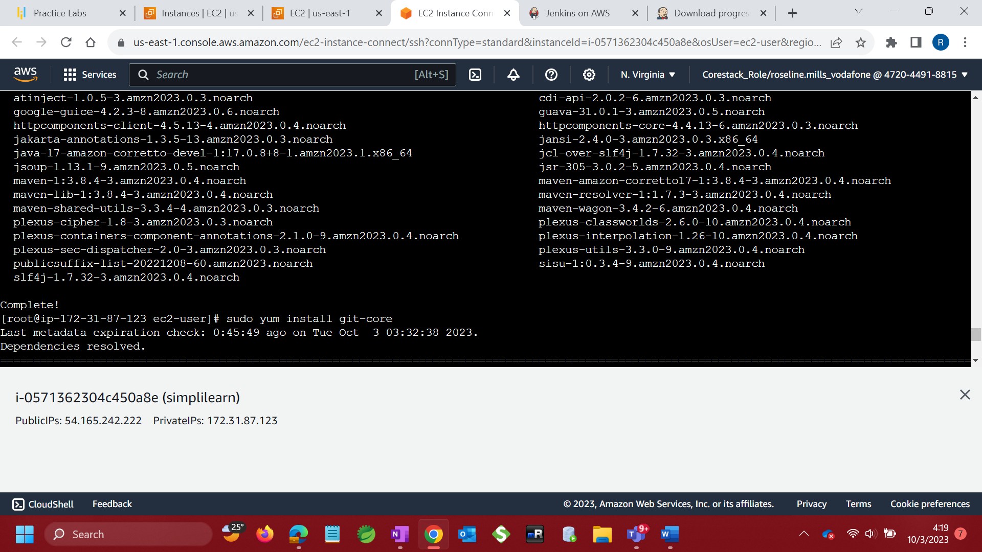

install git on EC2 instance

sudo yum install git-core

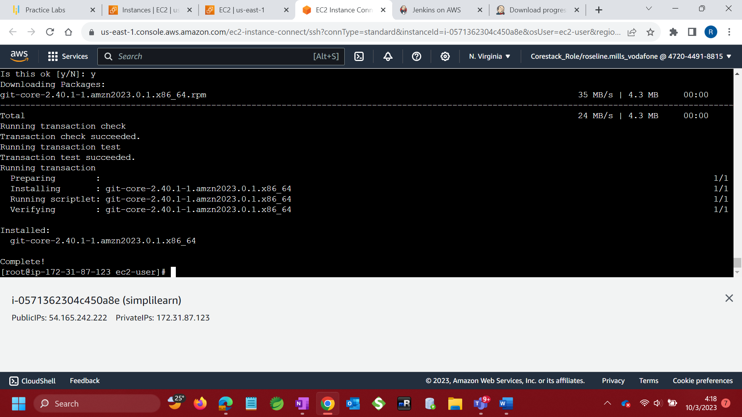

On Jenkins, configure Maven

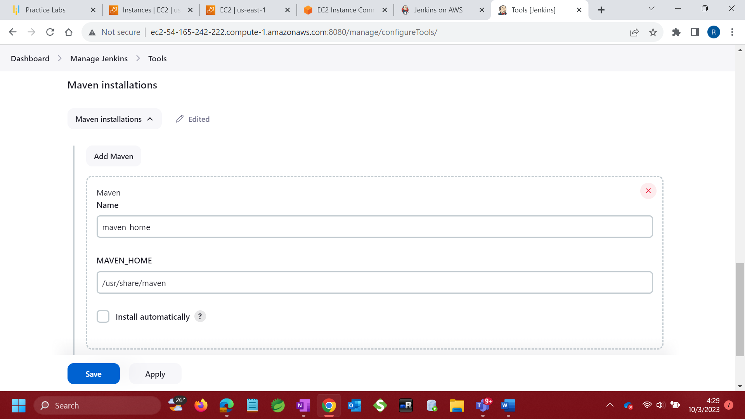

On Jenkins, configure JDK

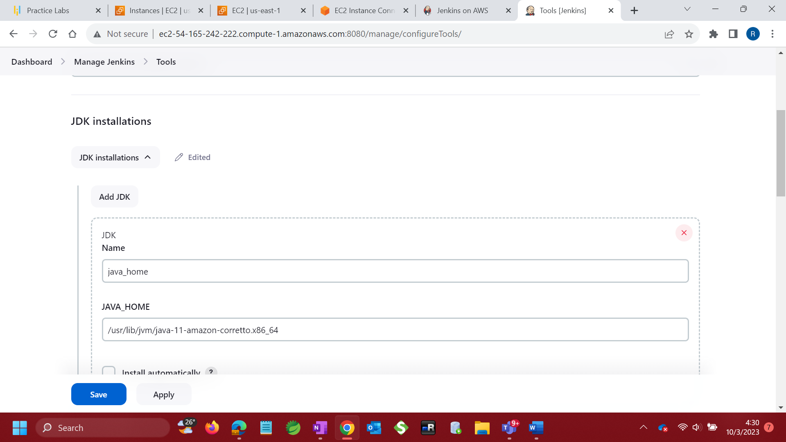

Install Maven & Oracle Java SE Development Kit (JDK)

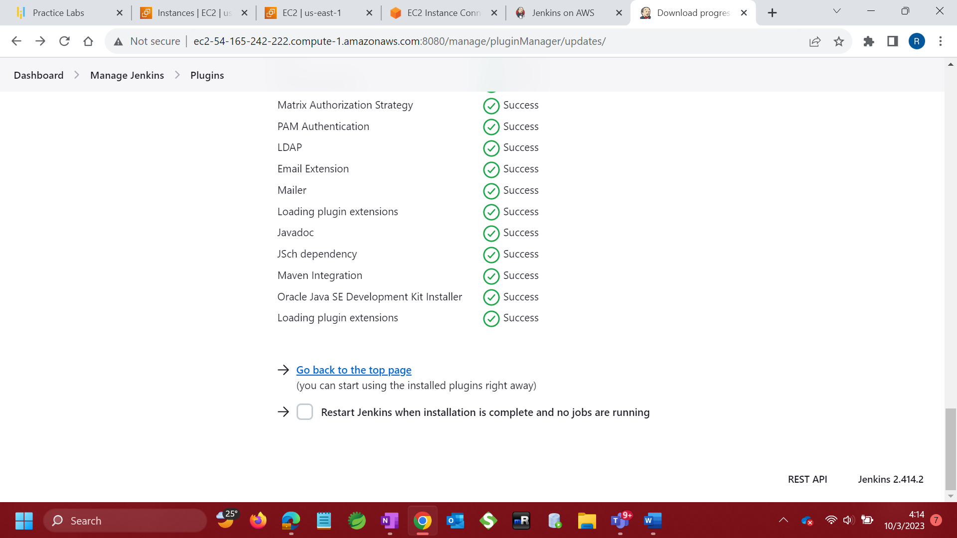

Configure maven job

